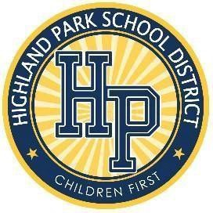
PUBLIC NOTICE OF REGULAR MEETING PLEASE TAKE NOTICE OF THE REGULAR MEETING
FOR THE BOARD OF EDUCATION OF HIGHLAND PARK SCHOOL DISTRICT

DATE OF MEETING: | September 9th , 2026  The Board of Education Members Meet at Barber Preparatory Academy (In Person) 45 E. Buena Vista Street  Highland Park, MI 48203 Join  Zoom Meeting:  https://us06web.zoom.us/j/84011473307?pwd=Qm pGaGM3TlMvOEYwU0pVa3R4N2hYQT09  Meeting ID: 840 1147 3307  Passcode: 955655
LOCATION OF MEETING:
TIME OF MEETING: TELEPHONE NUMBER OF  THE PRINCIPAL OFFICE OF THE | 6:00 p.m.
BOARD OF EDUCATION:  THE BOARD MINUTES ARE LOCATED AND  AVAILABLE FOR INSPECTION AT THE HPSD | 313-402-0266
OFFICE OF THE BOARD OF EDUCATION: | 12360 Woodward Avenue Highland Park, MI 48203
PURPOSE: | Regular scheduled Board Meeting
Yolanda Harrison, Secretary Board of Education

AMERICANS WITH DISABILITIES ACT NOTICE:
Any individual with a disability who require accommodations for participating or attending this meeting should contact the Board of Education at 313-402-0266 in advance of the meeting to request assistance.
MISSION STATEMENT: To provide a high-quality public education that assures students will receive a comprehensive learning experience which prepares them to compete in a global 21st century society.

